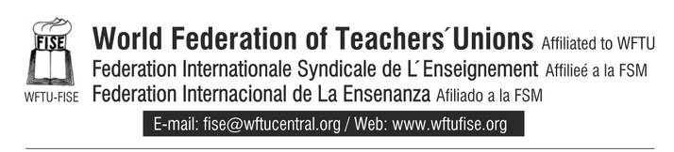 Sunday, 10th of March 2013

PRESS RELEASE

POLICE ATTACK IN A SCHOOL

MASSIVE TERRORISM IN NEIGHBORHOODS AND SCHOOLS IN THE HELLENIC TERRITORY….FOR THE GOLD

The inhabitants of Chalkidiki, in Greece move on with their struggle with rallies and massive protests. They totally disagree with the catastrophic plans of the multinational companies, that take advantage of the gold mines of the region. The police and the local authorities, on the other hand, defend the interests of those companies, intensifying more and more the authoritarianism and the terrorism, with locals’, employees’ and students’ adductions and arrests. They even fired huge amounts of tear gas and chemicals towards the students of a school, who were protesting in the courtyard, against the police operation, resulting in respiratory and other problems provocation of students and people working in the school.
The FISE denounces the police operation and expresses its solidarity to the struggle of the local people, who protest for their rights. We support the students, who protest and acknowledge the fact that there is no system, where the capital and the multinational companies live harmonically with the interests of the working class. Those who serve the multinational companies are enemies of the students’ parents, who belong to the working class.
The police attacks and the tear gas cannot cancel the class struggle. The government and the monopoles do not hesitate terrorizing even underage students, so that they secure their profits. We, however, can and must teach our students that they only way to defend and conquer our rights is the struggle against these violent strategies, that deprive us of all of our rights.

THE SECRETARY

